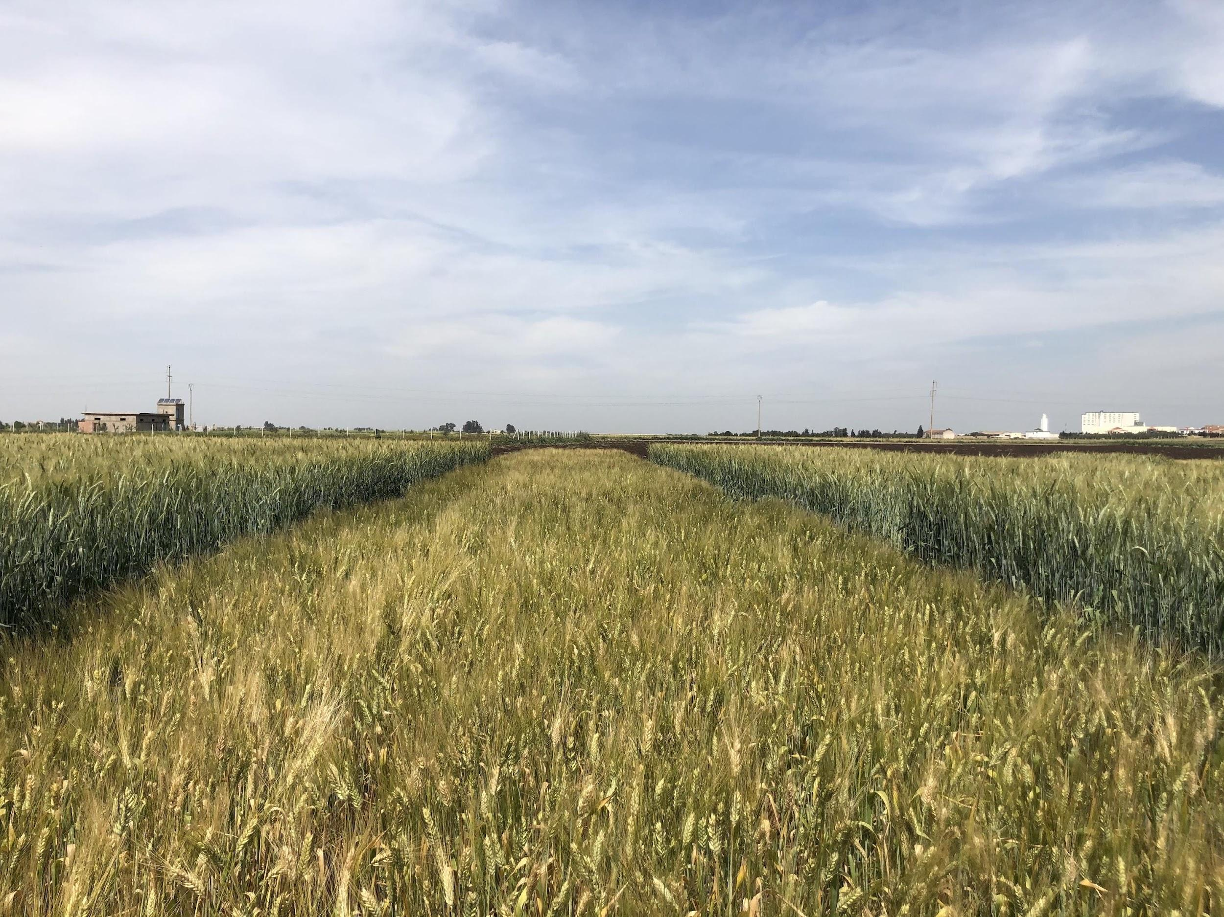
Jabal Durum Wheat
LAUNCH CAMPAIGN 2022

A new drought-tolerant variety of durum wheat called Jabal, developed together by scientists and farmers in a decades-long project, has been released for cultivation in Morocco.

🙌 Your support to promote and share through your networks is greatly appreciated.

Hashtags: #BOLDcwr #JabalWheat
Mentions: @CropTrust @ICARDA
Campaign page: https://bit.ly/3gLnPx5

About this toolkit
Jabal is a drought-tolerant variety of durum wheat developed together by scientists and farmers in a decades-long project. It has finally been released for cultivation in Morocco.

This toolkit was developed to enlist our partners, funders, interested organizations and individuals in amplifying Jabal’s key messages and in generating conversations online. We’ve developed social media messaging to make it easy for you to share our content and engage your audiences online.

Key messages
You can use this language when speaking about Jabal variety and its launch:
- The new “Jabal” variety was made by crossing cultivated durum wheat with one of its wild relatives, collected in Syria.
- Jabal, which means “mountain” in Arabic, was singled out by farmers in consultations with crop breeders because it adapted so well to drought, a common stress in its main cultivation areas.
- Durum wheat is grown primarily to produce pasta, but is also used for making couscous and bulgur, which are particularly popular in North Africa and the Middle East.
- Jabal was developed under the Crop Trust’s Crop Wild Relatives Project and durum wheat is one of the crops that will continue to receive support from the follow-up Biodiversity for Opportunities, Livelihoods and Development (BOLD) Project, a 10-year effort funded by the Government of Norway and led by the Crop Trust.
- The Crop Trust’s partners are using crop diversity to develop resilient varieties of barley, durum wheat, grasspea, alfalfa, finger millet, rice and potato that can withstand the effects of climate change.

Social media messaging
Feel free to copy and paste messaging below directly into your social media account, or adapt as needed.

When you post:
- Please use the BOLD Project hashtag and the Jabal hashtag:
  - #BOLDcwr
  - #JabalWheat
  - Tag @CropTrust and @ICARDA on Twitter
  - Tag @globalcropdiversitytrust and @icarda on Facebook
  - Tag @CropTrust and @icarda_cgiar on Instagram

 | Twitter | LinkedIn/Facebook | Instagram | Visual
1 | 🌾 Jabal’s drought-tolerance will help improve food security for durum wheat farmers in Morocco who are facing hotter and drier conditions under #climatechange.  https://bit.ly/3gLnPx5  @CropTrust @ICARDA #BOLDcwr #JabalWheat | 🌾 Jabal’s drought-tolerance will help improve food security for durum wheat farmers in Morocco who are facing hotter and drier conditions under climate change.  Unlike other durum wheat varieties grown in the region, Jabal’s wild genes enabled it to thrive despite some of the worst droughts farmers had seen.  https://bit.ly/3gLnPx5  #BOLDcwr  #JabalWheat | 🌾 Jabal’s drought-tolerance will help improve food security for durum wheat farmers in Morocco who are facing hotter and drier conditions under climate change.  Unlike other durum wheat varieties grown in the region, Jabal’s wild genes enabled it to thrive despite some of the worst droughts farmers had seen.  Visit @CropTrust's link in bio to learn more.  #BOLDcwr  #JabalWheat | Card 1
2 | Jabal is a new variety of durum wheat developed by scientists together with farmers. During testing, Moroccan farmers chose Jabal as their favorite for its:  ☀️ drought-tolerance  🌾 high-yield  ⛰️ black spike  🍞 good taste  https://bit.ly/3gLnPx5  #JabalWheat #BOLDcwr | Jabal is a new variety of durum wheat developed by scientists together with farmers. It has officially been registered for cultivation by the Moroccan Ministry of Agriculture, following a three-year testing program across Moroccan farms.  During testing, Moroccan farmers quickly singled out Jabal as their preferred variety for its:  ☀️ drought-tolerance  🌾 high-yield  ⛰️ black spike  🍞 good taste  https://bit.ly/3gLnPx5  #BOLDcwr  #JabalWheat | Jabal is a new variety of durum wheat developed by scientists together with farmers. It has officially been registered for cultivation in Morocco after three years of testing across Moroccan farms.  During testing, Moroccan farmers quickly singled out Jabal as their preferred variety for its:  ☀️ drought-tolerance  🌾 high-yield  ⛰️ black spike  🍞 good taste  Follow @CropTrust, #JabalWheat and #BOLDcwr to learn more. | Card 2
3 | A series of droughts between 2017-2021 caused the durum wheat in Moroccan farmers’ fields to fail. Except one – #JabalWheat  This new drought-resistant variety will help farmers adapt to #climatechange.  Find out more 👉 https://bit.ly/3gLnPx5  @CropTrust @ICARDA | A series of droughts between 2017-2021 caused the durum wheat in Moroccan farmers’ fields to fail. Except one – Jabal.  This new drought-resistant variety, developed by crossing a wild relative with durum wheat, will help Moroccan farmers adapt to hotter and drier conditions under climate change.  Learn more about its recent release in Morocco.  https://bit.ly/3gLnPx5  #BOLDcwr  #JabalWheat | A series of droughts between 2017-2021 caused the durum wheat in Moroccan farmers’ fields to fail. Except one – Jabal.  This new drought-resistant variety, developed by crossing a wild relative with durum wheat, will help Moroccan farmers adapt to climate change.  Follow @CropTrust and #BOLDcwr to learn more about its recent release in Morocco.  #BOLDcwr  #JabalWheat | Card 3
4 | A new drought-tolerant variety of durum wheat, Jabal means “mountain” in Arabic. It was named by Moroccan farmers who selected it as their top variety during field testing.  Learn more about its recent release: https://bit.ly/3gLnPx5  @CropTrust @ICARDA #BOLDcwr | A new drought-tolerant variety of durum wheat, Jabal means “mountain” in Arabic. It was named by Moroccan farmers who selected it as their top variety during field testing.  Jabal was developed by crossing durum wheat varieties with a wild relative collected by scientists in the plateaus of Syria.  Learn more about the recent release of this climate-resilient variety.  https://bit.ly/3gLnPx5  #BOLDcwr  #JabalWheat | Meaning “mountain” in Arabic, Jabal is a new drought-tolerant variety of durum wheat. It was named by Moroccan farmers who selected it as their top variety during field testing.  Jabal was developed by crossing durum wheat varieties with a wild relative collected by scientists in the plateaus of Syria.  Learn more about the recent release of this climate-resilient variety.  https://bit.ly/3gLnPx5  #BOLDcwr  #JabalWheat | Card 4
5 | 40 years ago, @ICARDA scientists ventured into the Syrian plateaus to retrieve the seeds of a wild grass that could withstand drought. This was bred with durum wheat to produce a new drought-tolerant variety called #JabalWheat  👉https://bit.ly/3gLnPx5  @CropTrust #BOLDcwr | 40 years ago, scientists ventured into the Syrian plateaus to retrieve the seeds of a wild grass that could withstand drought - Aegilops speltoides.  This wild relative of durum wheat was bred with cultivated varieties to produce the new drought-tolerant Jabal variety.  After decades of work, Jabal has now officially been released for cultivation in Morocco.  https://bit.ly/3gLnPx5  #BOLDcwr  #JabalWheat | 40 years ago, scientists ventured into the Syrian plateaus to retrieve the seeds of a wild grass that could withstand drought - Aegilops speltoides.  This wild relative of durum wheat was bred with cultivated varieties to produce a new climate-resilient variety called Jabal.  After decades of work, Jabal has now officially been released in Morocco. Visit @CropTrust's link in bio to learn more.  #BOLDcwr  #JabalWheat | Card 5
6 | Crop wild relatives can have useful traits crucial for future food security as farmers adapt to a changing climate.  Learn more about #JabalWheat 👉 https://bit.ly/3gLnPx5  @CropTrust @ICARDA #BOLDcwr | Crop wild relatives can have useful traits that are crucial for future food security as farmers adapt to a changing climate.  Learn more about Jabal, a new drought-resistant durum wheat variety released for cultivation in Morocco.  https://bit.ly/3gLnPx5  #BOLDcwr #JabalWheat | Crop wild relatives can have useful traits that are crucial for future food security as farmers adapt to a changing climate.  Learn more about Jabal, a new drought-resistant durum wheat variety released for cultivation in Morocco.  Visit @CropTrust's link in bio to learn more.  #BOLDcwr #JabalWheat | Photo 1
7 | Durum wheat is the 10th most commonly cultivated cereal worldwide. This key food is under threat from hotter and drier conditions, reducing yields.  A new drought-tolerant variety called #JabalWheat is helping farmers adapt: https://bit.ly/3gLnPx5  @CropTrust @ICARDA #BOLDcwr | Durum wheat is the 10th most commonly cultivated cereal worldwide. A new drought-tolerant variety called Jabal has been released in Morocco, helping to improve food security for farmers who are facing hotter and drier conditions under climate change.  Find out more about the decades-long project to develop this climate-resilient variety 👉 https://bit.ly/3gLnPx5  #BOLDcwr  #JabalWheat | Durum wheat is the 10th most commonly cultivated cereal worldwide. A new drought-tolerant variety called Jabal has been released in Morocco, helping to improve food security for farmers who are facing hotter and drier conditions under climate change.  Find out more about the decades-long project to develop this climate-resilient variety  👉 Visit @CropTrust's link in bio to learn more.  #BOLDcwr #JabalWheat | Photo 2

